[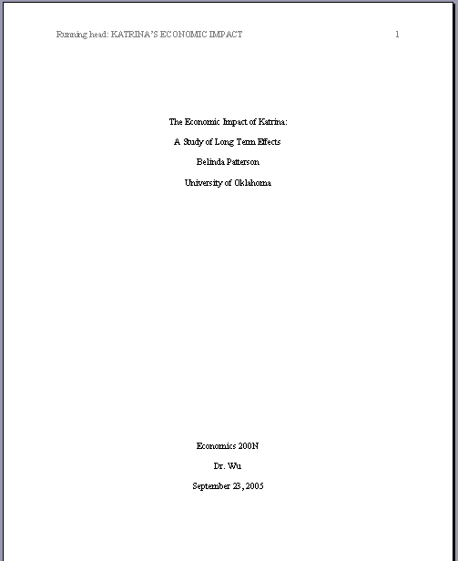](http://www.google.ca/url?sa=i&rct=j&q=&esrc=s&source=images&cd=&cad=rja&uact=8&ved=0ahUKEwiSnrf99pDLAhWhtYMKHXBlAs4QjRwIBw&url=http%3A%2F%2Fthewritedirection.net%2Fdrpaper%2Fhelp%2F05-03-apastyle-cover.htm&psig=AFQjCNHlzsSiKQor-kHVINOFTyMw727gDw&ust=1456421392948084)